

**Department of Computer Science And Engineering**

Spring 2022-2023

**Project Report**

**Face Recognition Attendance System**

|  |  |  |
| --- | --- | --- |
|  | **Team Members** |  |
|  |  |  |
|  | **Student Name** | **Student ID** |
| **1** | Shubham Bharti | 19011004084 |
| **2** | Ankush | 20011004505 |
|  |  |  |
|  |  |  |

**Project Advisors:**

Advisor Name: Mrs Rashika

**Declaration**

We do hereby declare that the report entitled “Face Recognition Attendance” submitted by us to Aravali College of Engineering and Management, Faridabad in partial of the requirement for the award of the degree of B. TECH in COMPUTER SCIENCE AND ENGINEERING is a record of Bonafede project work carried out by us under the guidance of and Department of Computer Science and Engineering.

ShubhamBharti(19011004084)

Ankush (20011004505)

PLACE-FARIDABAD DATE: 23December,2022

**CERTIFICATE**

This is to certify that the project entitled “Vision Project” is a Bonafede work done by Shubham Bharti(19CSE84) and Ankush(20LCSE05) of 6th Semester B.Tech in Computer Science and Engineering from Aravali College Of Engineering and Management, Faridabad under the guidance of **Mrs. Rashika** in the partial fulfilment of the requirement of the award for the Degree of B.TECH. in COMPUTER SCIENCE AND ENGINEERING in Aravali College of Engineering and management, Faridabad.

**Project Guide:** Mrs. Rashika(Department of Computer Science and Engineering )

Place – Faridabad

Date – 23December, 2022

External

**ACKNOWLEDGEMENT**

We had a great experience working on this project and we got to learn a plethora of new skills through this project. However, it would not have been possible without the kind support and help of many individuals. We would like to extend our sincere thanks to all of them. We are highly indebted to the teachers and especially Mrs. Rashikafor their guidance and constant supervision as well as providing necessary information regarding the project and also for their support in completing the project. We would like to express our gratitude towards our parents and friends for their kind cooperation and encouragement which help us in the completion of the project.

Shubham Bharti (19011004084)

Ankush (20011004505)

**PLACE- FARIDABAD**

**DATE: 23December, 2022**

**Table Of Content**

|  |  |  |  |
| --- | --- | --- | --- |
|  | **Abstract** ........................................................................................................................................................... | | 3 |
| **1.** | **Introduction** .................................................................................................................................................... | | 4 |
|  |  | **Project Definition** ....................................................................................................................................... | 4 |
|  |  | **Project Objectives** ...................................................................................................................................... | 4 |
|  |  | **Project Specifications** ................................................................................................................................. | 4 |
|  |  | **Product Architecture and Components** ................................................................................................... | 5 |
|  |  | ***Functional Diagram*** .............................................................................................................................. | 5 |
|  |  | ***User Interface Image*** .............................................................................................................................. | 6 |
|  |  | **Applications** ................................................................................................................................................ | 6 |
| **2.** | **Literature Review** ................................................................................................................................................ | | 7 |
|  | **1** | **Project background** .................................................................................................................................... | 7 |
|  |  | **Previous Work** ............................................................................................................................................ |  |
|  | **3** | **Comparative Study** ................................................................................................................................ |  |
| **3.** | **System Design** .................................................................................................................................................. | |  |
|  | **3** | **Design Constraints** ................................................................................................................................... |  |
|  | ***Design Constraint: Engineering Standards*** ....................................................................................... | |  |
|  | ***3*** | ***Design Constraint: Environmental*** .................................................................................................... |  |
|  |  | ***Design Constraint: Ethical*** ................................................................................................................. |  |
|  |  | **Design Methodology** ............................................................................................................................... |  |
|  |  | **Product Subsystems and Components** ................................................................................................. |  |
|  | ***Product Subsystem1: Vision Acquisition*** ........................................................................................... | |  |
|  | ***Product Subsystem2: Grayscale Conversion*** ...................................................................................... | |  |
|  | ***Product Subsystem3: Vision Assistant*** ............................................................................................... | |  |
|  | ***Product Subsystem4: Writing in a Measurement File*** ....................................................................... | |  |
|  |  | **Implementation** ...................................................................................................................................... |  |
| **4. System Testing and Analysis** ........................................................................................................................... | | |  |
|  |  | **Subsystem 2: Vision Acquisition** ........................................................................................................... |  |
|  |  | **Subsystem 2: Vision Assistant** ............................................................................................................... |  |
|  |  | **Overall Results, Analysis and Discussion** ............................................................................................. |  |
| **5.** | **Project Management** ....................................................................................................................................... | |  |
|  |  | **Project Plan** .......................................................................................................................................... |  |
|  |  | **Contribution of Team Members** ......................................................................................................... |  |

|  |  |  |  |
| --- | --- | --- | --- |
|  | **6** | **Project Execution Monitoring** ............................................................................................................. |  |
|  |  | **Limitation and Challenges** .................................................................................................................... |  |
|  |  | **Project Bill of Materials and Budget** .................................................................................................... |  |
| **6.** | **Project Analysis** ............................................................................................................................................... | |  |
|  |  | **Life-long Learning** ................................................................................................................................. |  |
|  |  | **Impact of Engineering Solutions** ........................................................................................................... |  |
|  |  | **Contemporary Issues Addressed** ............................................................................................................ |  |
| **7.** | **Conclusions and Future Recommendations** .................................................................................................... | |  |
|  |  | **Conclusions** ............................................................................................................................................... |  |
|  |  | **Future Work and Expected Final Prototype/Results** ............................................................................ |  |
|  |  | **Future Recommendations** ....................................................................................................................... |  |
| **8.** | **References** .......................................................................................................................................................... | | 1 |

**Abstract**

Face detection and face recognition are very important technologies these days, furthermore we noticed that they got have a variety of uses such as cellphones, army uses, and some high risk information offices. We decided to make a device that detects and recognize the face as a student attendance system and can be a substitute for the regular paper attendance system and finger print attendance system. The main function in our project is going to be done using LabVIEW because, LabVIEW is a very helpful programming tool in regards of facial uses and very helpful in other uses. Our project is based on a main program in LabVIEW that detects and recognize faces with giving scores and parameters, furthermore the subsystems are an Excel sheet that is integrated with the program, and a messaging device that is for either a message for absent students or to the student’s parents. Components of our project are LabVIEW program as the main system and subsystems, Office Excel sheet to include students names, and a computer (or laptop) to integrate the programs together.

**Chapter:1**

**INTRODUCTION**

**1.1** **Project Definition**

A person’s face has distinctive physical shape and characteristics that are used to identify or verify an individual. Facial recognition records this biometrics of the face. Different face recognition methods measure the biometric of the face. Facial recognition has become a very important topic in recent years. Facial recognition is effectively applied in various applications like security systems, authentication, entrance control, surveillance system, unlocking of smartphones and social networking systems, etc. Most of the practices do not use facial recognition as the main form of conceding entry. However, with advancement in technology and algorithm, facial recognition system has the potential to replace the standard passwords and fingerprint scanners.

[1]

This project was carried out to show how a Local Binary Pattern Histogram (LBPH) face recognizer could be used for taking attendance of students. LBPH facial recognizer is a pretrained facial recognition classifier. If enough data set are available on the face that is needed to be identified, LBPH can perform facial recognition with high accuracy. Face Recognition Student

Attendance System is a desktop application that identifies and verifies student’s identities with the help of a digital image. Once the recognized face matches with the stored image, the attendance is completed and marked in the database for the student. This system will provide an alternative and easier way of taking attendance.[2]

The facial recognition system has three main phases, which are described below:

### Face Detection

Face detection is the ability to identify the person’s faces within the digital images. This system identifies the human face present in an image or video. We need to define a general structure of a face to determine certain picture or video contains a face (or several). Human faces have the same features such as eyes, nose, forehead, mouth, and chin. Therefore, the objective of face detection is to find the location and size of the face in an image. The located face is then used by the facial recognition algorithm.

Feature Extraction

In this phase, we are extracting the features from the detected face. In LBPH, the first local binary pattern images are computed, and a histogram is created for facial recognition. This generates a template. A template is a set

**Project Objectives**

1. Reducing time wastage during conventional class attendance.
2. Utilizing latest trends in machine vision to implement a feasible solution for class attendance system.
3. Automating the whole process so that we have digital environment.
4. Preventing fake roll calls as one to one attendance marking is possible only.
5. Encouraging the use of technology in daily lives.

**Project Specifications**

1. Uses Pattern Matching algorithm for face detection.
2. Score of minimum 600 required to perfectly match a face.
3. Metric: Camera Resolution.
4. For prototype fixed to 10 users only but scalable design.
5. Requires good lighting condition for better camera capture capability.
6. Attendance sheet is .xlsx format and can be digitally distributed and maintained.

## History of Facial Recognition

Woody Bledsoe, Helen Chan Wolf, and Charles Bisson were the earliest pioneers of facial recognition. They began working to recognize the human face using a computer in 1964 and 1965. They marked various landmarks on the face such as eye centers, nose, mouth manually. They later used the computer to mathematically rotate to compensate for pose variation. The distances between the facial landmarks were computed automatically and compared with the image to match the identity. This was the dawn of facial recognition.

Sirovich and Kirby applied linear algebra to facial recognition and made it a viable biometric for business. They developed a system called “Eigenface” where less than one hundred values were required to code the facial image accurately. In 1991, the discovery of face detection within an image by Turk and Pentland led to the beginning of automated facial recognition. This paved the way for the advancement and development of facial recognition technology. FERET program was rolled out in the early 1990s by the DARPA and NIST for commercial facial recognition. They created a database for facial images, which included 2413 facial images that represented 856 people. In the early 2000s, to provide independent government evaluations of facial recognition system and its prototype technologies, FRVTs was designed. These evaluations provided the necessary information to deploy the facial recognition technology in the best way to the law enforcement agencies and government. Face Recognition Grand Challenge was launched in 2006 to evaluate the face recognition algorithms available. It used high-resolution images, 3D face scans, and iris images for the test. The test concluded that the new algorithm was 10 times more accurate than the algorithms of 2002 and more than 100 times more accurate than the algorithm of 1995. In recent years, Facebook has implemented facial recognition functionality to identify people featured in the user’s daily updates. In 2017, Apple launched the iPhone-X, which was the first iPhone to implement facial recognition to unlock the phone.[3]

## Importance of Facial Recognition System

Applications using facial recognition systems are widespread. They are applied in security systems, authentication systems, verification systems, surveillance systems, etc. We are interacting with face recognition systems without even realizing it. Many Businesses are using facial recognition systems for authentication, verification, and security. There are diverse applications of this system. Countries such as United States, United Kingdom, and Australia are now installing facial recognition technologies in different public spaces such as airports, cafes, shopping areas, factory areas, and government buildings. A large retail company like Alibaba is working on the development of pay-by-face technology. Workspaces are using this technology to record the clock in and clock out tine of the employees. Law enforcement agencies are installing cameras with facial recognition systems to identify criminals and search for missing persons. As facial recognition technology and algorithms advance, we would see it being implemented more and more in our society. [4]

## Challenges of Facial Recognition System

A facial recognition system can revolutionize how businesses and governments interact with people. However, if not used properly, there are potential pitfalls with this technology. Potential misuse of personal and sensitive information is very real. Businesses and Organizations need to make sure that there are proper checks and balances and proper security before implementing this technology. Every time this technology scans someone’s face, the distinct biometrics of the person is stored in a database. Depending on who owns the database and security in place to protect the database, the information can be leaked, stolen, or misused without the consent of the person. Facial recognition systems are not perfect. Data collected by humans are used to train the algorithms. If there are a lack of data and a diverse array of data to train the algorithms, the system can misidentify the person. There have been many instances where the system incorrectly identified the gender or identity of people with darker skin tones. This happened because of a lack of data representing a diverse array of people. [4]

With the advancement of new technology comes a new type of crime. Criminals could access the facial recognition data by hacking the database and track people’s movement, location, and information without their consent. Criminals can cause significant damage with the aid of a facial recognition system. They can steal sensitive personal information or the identity of a person to commit a crime.

The application of facial recognition technology holds many promise. However, it needs to be handled carefully. Businesses that want to implement this technology need to implement the proper framework and facial data protection measures. If successfully managed to implement this technology, they can reap the benefits of this technolog

**1.4** **Product Architecture and Components**

***1.4.1*** ***Functional Diagram***

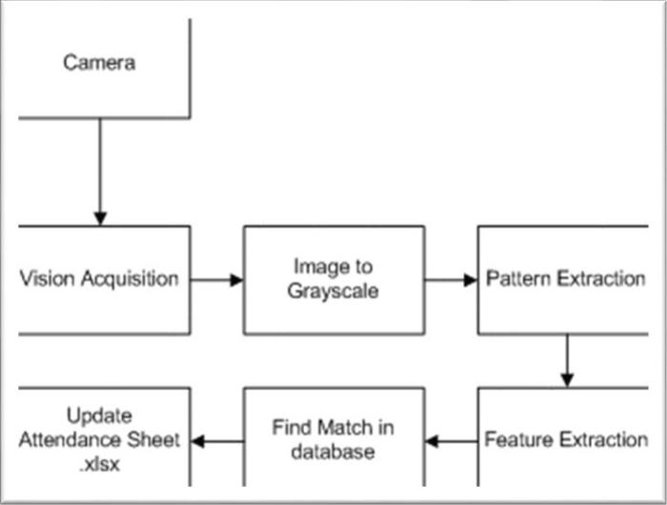

**FIGURE 1.1: BLOCK DIAGRAM OF THE SYSTEM**

The subsystem description is as follows:

**Camera:** The camera is the only hardware component required to capture live video feed of class.

**Vision Acquisition:** This module allows image to be captured by camera into LabVIEW for programming. It includes IMAQ submodules such as IMAQ Create, IMAQdx Open, IMAQdx Grab. They all combine to provide Continuous Acquisition of video feed from camera module.

**Image to Grayscale:** This process is performed using IMAQ ExtractSingleColorPlane VI to convert a 32/16bit image to 8bit image. This is a requirement for our pattern matching algorithm to work completely.

**Pattern Extraction:** This is included in Vision Assistant VI which deals with our face recognition algorithm. Pattern Extraction is feature in which the image inputted features are compared using Pattern Matching Algorithm.

**Feature Extraction:** This feature is used to extract important features out of image. It compares them with templates, saves in database and provides a score of comparison.

**Find Match in database:** Our database has preserved templates or images of students which we aim to recognize and mark attendance. This database can be updated or appended according to

requirement. This database is used for comparison with extracted feature of image to confirm a successful hit.

**Update Attendance Sheet.xlsx:** If match is found our algorithm updates the attendance of user corresponding to his/her name in excel file of format .xlsx. If not, the system marks absent in front of his/her name in the same excel file.

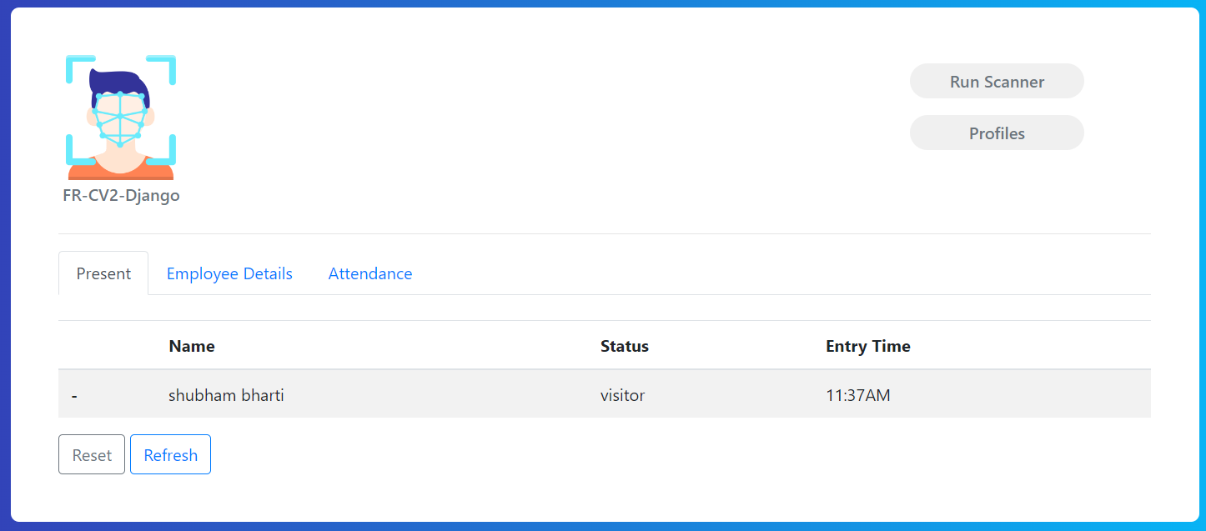

***1.4.1*** ***User Interface Image***

This is the front panel of LabVIEW program that the user is going to be using. It shows the attendance sheet with the names of the students, and a live camera of the user in front of the camera.

**1.5** **Applications**

1. Large application in institute attendance system where multiple attendances are carried out for different classes. The attendance will be short timed and reduce manual errors.
2. Large application of computer vision in field of Communication, Biomedical, Automatic Product Inspection.

**Chapter:2**

**LITRATURE AND REVIEW**

**2.1** **Project background**

In the face detection and recognition system, the process flow is initiated by being able to detect the facial features from a camera or a picture store in a memory. The algorithm processes the image captured and identifies the number of faces in the image by analyzing from the learned pattern and compare them to filter out the rest. This image processing uses multiple algorithm that takes facial features and compare them with known database.

The motivation behind this project is to simplify the means by which attendance is taken during lectures and how much time it takes. The use of ID cards or manually calling out attendance and writing it down on sheets is not productive and efficient. This system will detect the number of faces on the class and will also identify them from the store database. With the face detection and recognition system in place, it will be easy to tell if a student is actually present in the classroom or not.

**2.2** **Previous Work**

**PROJECT # 1**

This is a project done by students as a final year project at Kingston University London in 2018.

The system will be presented an image either via camera or from memory and it must detect the number of faces on it automatically. After identifying faces, the system should crop the faces from the image and store them in memory for image recognition which will be done in the second step. The system should be able to automatically count the number of faces detected on the image.

The second step will be the recognition part where the system will be able to match faces from the stored dataset and compare it to the input data from the first step. A software will be used for this system which automatically sorts out the faces. The software will be inter-active so to facilitate interaction between multiple tasks as required. Because the system has two steps, the second phase of the system will involve the training of images on a dataset that are to be used for recognition.

The system behavior has been explained in the following flowchart

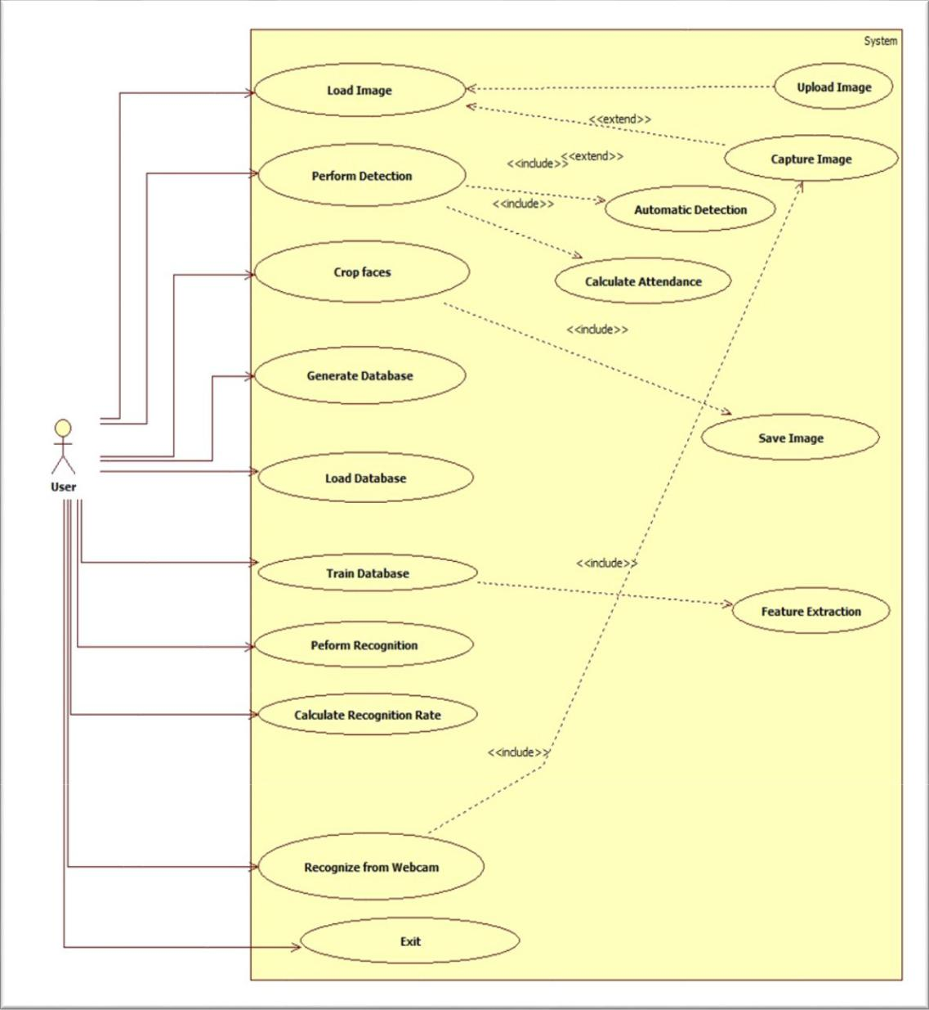

**FIGURE 2.1: BLOCK DIAGRAM OF PREVIOUS PROJECT #1**

**Technology Used**

The key algorithms are Viola-Jones for face detection and Hidden Markov Model with SVD.

The implementation of The Viola-Jones algorithm is available on softwares like MATLAB, OpenCV and Web Browsers (using adobe flash).

The existing implementation of the Hidden Markov Model with SVD for face recognition are available on MATLAB, C++ and OpenCV libraries.

**PROJECT # 2**

This is a project done by students as a final year project at University of Nairobi in 2012.

The system will comprise of two modules. The first module a.k.a face detector is a mobile component, which is basically a camera that captures student faces and stores them in a file using computer vision face detection algorithms and face extraction techniques. The second module is a desktop application that does face recognition of the captured images (faces) in the file, marks the students register and then stores the results in a database for future analysis.

Following flowchart explains the process of the flow of information throughout the process.

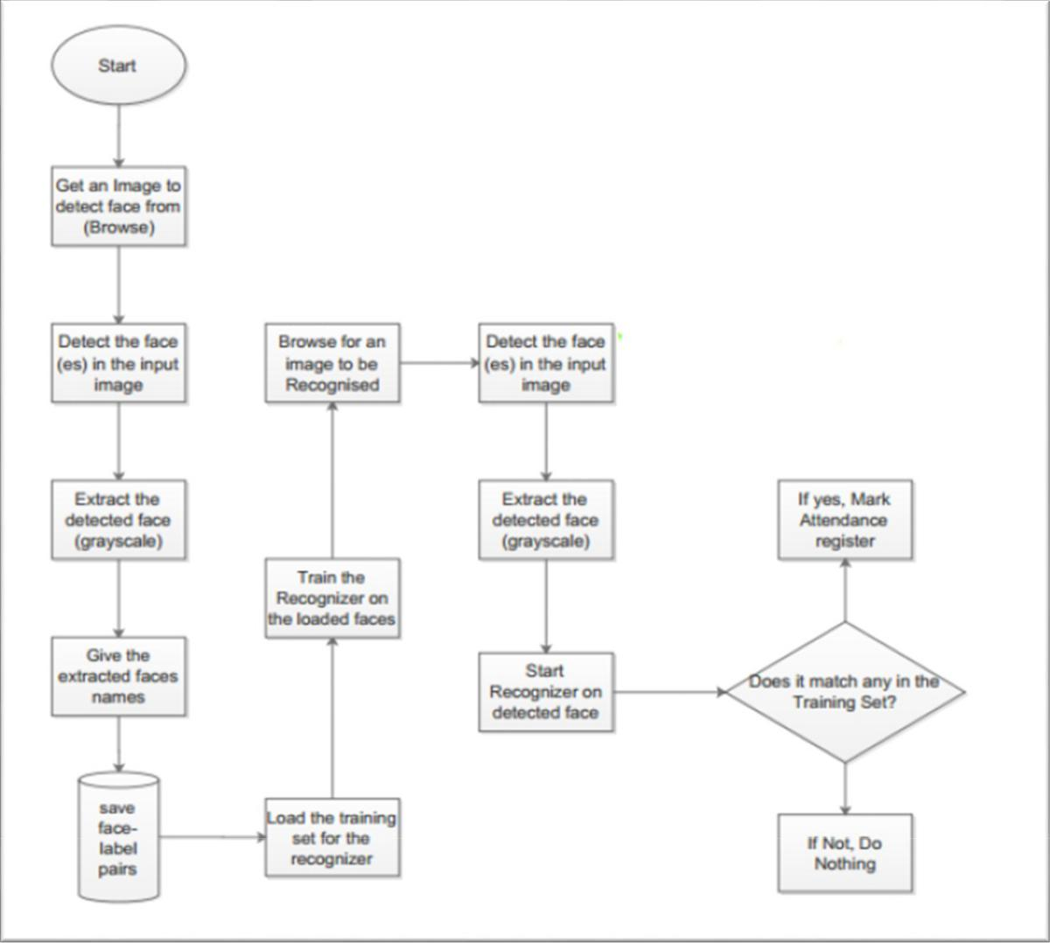

**FIGURE 2.2: BLOCK DIAGRAM OF PREVIOUS PROJECT #2**

******Technology Used**

The following tools will be used in the implementation of the designed system. They’ve been divided in to two categories; Mobile and Desktop tools.

**Mobile Tools**

The face detection module will use OpenCV library for implementation by use of the frontal Haar Cascade face detector in either Android studio.

**OpenCV for Android Library -** (Open Source Computer Vision) is a library of programming functions mainly aimed at real-time computer vision.

**Android Studio/ Eclipse IDE -** Android Studio is the official IDE for Android application development, based on IntelliJ IDEA.

**Desktop Tools**

**EmguCV Library -** EmguCV is a cross platform .Net wrapper to the OpenCV image processing library. OpenCV/EmguCV uses a type of face detector called a Haar Cascade. The Haar Cascade is a classifier (detector) trained on thousands of human faces.

**Visual Studio** - Visual Studio is able to build and run the solution examples after a proper configuration of EmguCV. The desktop software will implement the two sub-systems (Training set manager and Face recognizer) together with face detector in windows form.

**PROJECT # 3**

This is a project done by students as a final year project at Universiti Tunku in 2018

The approach performs face recognition-based student attendance system. This method is also similar to others and begins with the input of an image either loaded from memory or from camera. Then it pre-processes the facial features and extracts it followed by subjective selecting and then the recognition of the facial images from known database. Both LBP and PCA feature extraction methods are studied in detail and computed in this approach in order to make comparisons. LBP is enhanced in this approach to reduce the illumination effect. An algorithm to combine enhanced LBP and PCA is also designed for subjective selection in order to increase the accuracy.

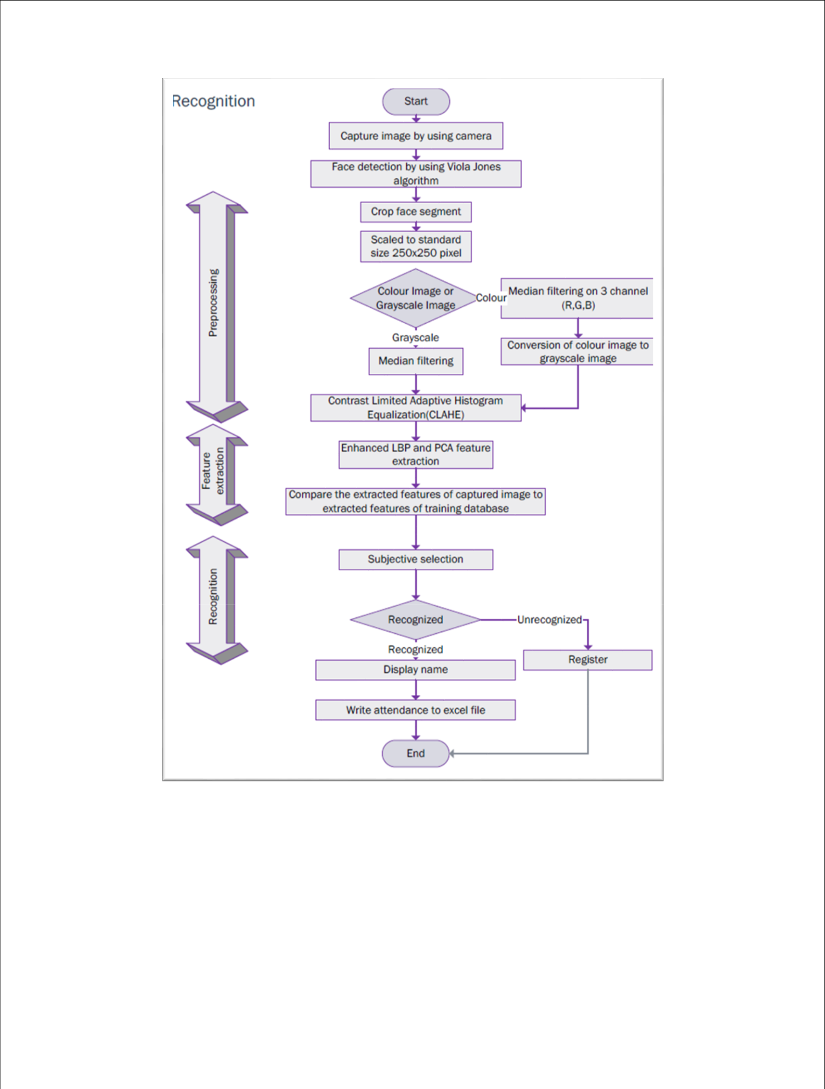

**FIGURE 2.3: BLOCK DIAGRAM OF PREVIOUS PROJECT #3**

The project is completely built with OpenCV libraries implemented in it.

**2.3** **Comparative Study**

Our project is different than all the previous projects made and mentioned above. They have purely used the core of machine vision to implement a face detection mechanism. None of the above-mentioned projects have realized the power of LabVIEW programming and LabVIEW Vision modules in which not only pattern matching but other machine vision algorithms like edge tracking, geometric matching can be implemented with ease.

Though the general mechanism and flow of events is similar in above projects and our current project however, the mechanism of face detection is completely unique and different.



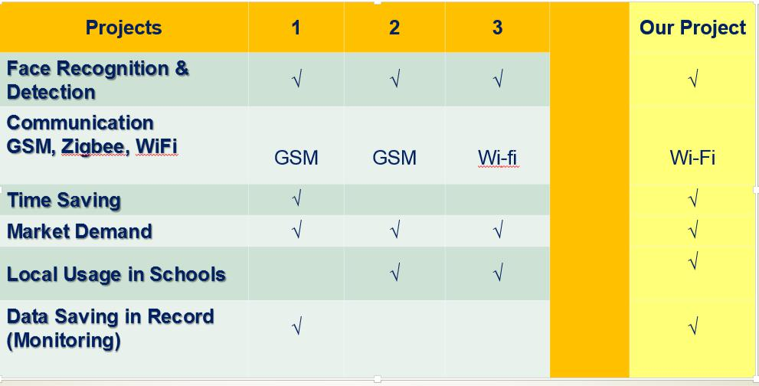

**FIGURE 2.4: COMPARESSON BETWEEN ALL PROJECTS**

**Method and Materials**

This is the most important section of the thesis. This section describes the detailed workflow of the project and the necessary theoretical background.

Too and Technologies.

## Tools and Technologies

Tools and techniques used in the project are described in this section of the thesis. This project focused was mainly focused on Python Programming and its libraries.

## Python

Python is a high-level object-oriented programming language. It was created by Guido van Rossum in 1991 as Python 0.9.0. It was created as the successor of the ABC programming language. Python 2.0 was released on 16 October 2000 and added many features like list comprehension and garbage collecting system. On 3 December 2008, Python 3.0 was released. Python is a very popular programming language and can be used for various purposes. It is widely used for web development, software development, mathematics and data analysis, system scripting, etc. Python is a multi-purpose programming language that works on different platforms like Windows, Linux, Mac, Raspberry Pie, etc. Python is popular than other programming languages because it has a simple syntax than other programming languages. Its syntax allows the programs to write code that is easier to understand and in fewer lines. It runs in an interpreter system. Hence, the code can be executed as soon as it is written.[5]

In this thesis, we use Python for web development. This project demonstrated how Python is used for an effective and reliable web application. Various Python frameworks, libraries are used in this project.

**Django**

Django is a high-level web framework based on python. Django was developed between 2003 and 2005 by a team responsible for creating and maintaining newspaper sites. It has continued to grow by releasing Django 1.0 in 2008 through the latest Django 3.1 in 2020. It enables users with rapid and secure development of the websites. It is open source, free with a thriving community, and has up-to-date documentation. Any kind of website can be built using Django. It works on any framework and delivers content in any format (JSON, HTML, XML, etc). Django provides a security framework that helps developers protect their websites. Django uses component-based architecture. It means each component is independent of the other, hence can be easily changed or replaces if needed. It provides a clear separation of different parts that enables to scale for increased traffic at any level by adding hardware. Django uses the Do not Repeat Yourself (DRY) principle. Hence, there is no unnecessary repetition of code. Django is written in Python and hence, can be run on my platforms. [6]

## OpenCV

OpenCV is an open-source machine learning and computer vision library. OpenCV is a crossplatform library and is free to use. It was launched in 1999. Intel launched OpenCV to advance CPU-intensive applications. It was developed in C++. It provides bindings for Java and Python programming languages. It runs in different operating systems such as Linux, Windows, OSx, etc. It focuses mainly on video capturing, image processing, and analysis. It has face detection and objects detection features. OpenCV can be used to read and write images and capture and save videos. It can perform feature detection like faces, cars, images, etc. Many established companies like Yahoo, Google, Microsoft, Intel, and many others use the library.[7]

* 1. **Implementation**

This section describes how the algorithm was implemented to design the system and the testing of the system. The application was created using Python’s Django framework. Both the front-end and back-end of the project were done using Django. This project implements the tools and technologies mentioned in section 4.1. 4.2.1

* System Design

The project follows three-layered architecture, which is described below.

* Presentation Layer

This layer is responsible for the user interface. All the components that users see and interact with within the application are in this layer. Application Layer

* Application layer

controls the overall functionality of the system. Functionality such as logging into the system, facial detection, and recognition is all done in this layer.

* Data Layer

In this layer, Data and Information are stored and retrieved in the database. The names, images of students as datasets, teaches are stored in the database. Once the face is matched, marking of attendance in the database. See figure 4.

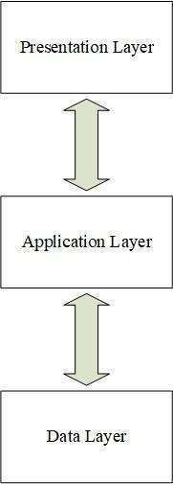

Figure 4 System Design

**Requirement Analysis and Feasibility Study**

This section of the thesis describes the requirements necessary for the project and its feasibility.

## Literature Review

A camera is set up in the classroom that scans the facial structure of the students. The detected face is extracted for further processing. Image of students are stored in the database as the dataset. These datasets are used to compare the biometrics with the detected face for facial recognition. Facial recognition is done using LBPH. LBPH extracts the histogram of the image and concatenates it to form the face descriptor by segmenting the image into the local region. The distance between the biometrics of the probe image and the trained image is calculated. If the calculated distance is less than the threshold, then the probe image is recognized. Once recognized, the name is updated into list.

## Requirement Analysis

In this section, the functionalities need to run the system are described.

## Functional Requirements

The system has different functionalities for an admin and teachers. Admin has higher privileges than teachers. Their functionalities are described below.

Admin Module

Admin has the highest privileges among all as admin is responsible to design the system.

Admin register teacher and provide unique id to the teacher.

They are responsible to take images of the students and add them to the database.

Admin can view and update the details of both students and teachers.

They can also view the attendance report. Figure 1 shows the use case for admin,

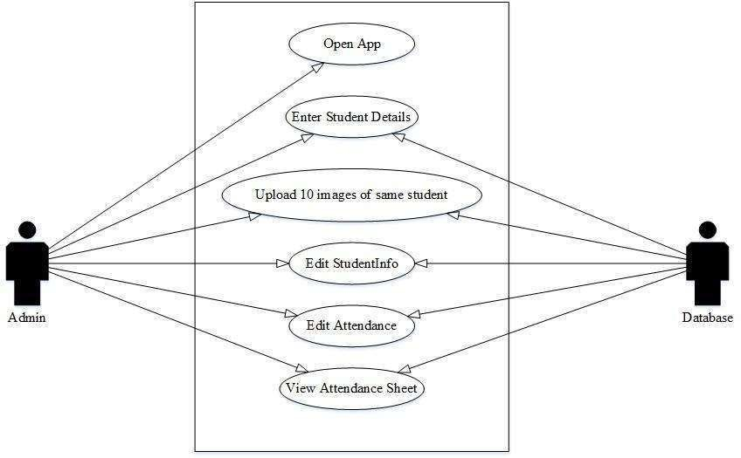

OPEN

Upload one image of student

Figure 1 Use Case User Module

**Non-Functional Requirements**

Non-Functional Requirements are the characteristics or attributes of the system that are necessary for the smooth operation of the system. Those requirements are listed below.

* + - * The system should perform the process accurately and precisely to avoid problems.
      * The system should be easy to modify for any updates. Any errors or bugs that are identified should be easy to mend.
      * The system should be secure and maintain the privacy of the students.
      * The system should be easy to understand and use.
      * Execution of the operation should be fast.

## Feasibility Analysis

A feasibility study evaluates the project's potential for success; therefore, perceived objectivity is an important factor in the credibility of the study for potential investors and lending institutions. . It must therefore, be conducted with an objective, unbiased approach to provide information upon which decisions can be based. Here, we discuss 3 major feasibility studies required for our project.

**Operational Feasibility**

Operational feasibility is the measure of how well a proposed system solves the problems with the users. Operational feasibility is dependent on human resources available for the project and involves projecting whether the system will be used if it is developed and implemented. The project is operationally feasible for the users as nowadays almost all the teachers/staffs are familiar with digital technology.

## Economic Feasibility

Economic feasibility defines whether the expected benefit equals or exceeds the expected costs. It is also commonly referred to as cost/benefit analysis. The procedure is to determine the benefits and the savings expected from the system and compare them with the costs. A proposed system is expected to outweigh the costs.

This is a small project with no cost for development. The system is easy to understand and use. Therefore, there is no need to spend on training to use the system. This system has the potential to grow by adding functionalities for students as well as teachers. This can Hence, the project could have economic benefits in the future.

## Technical Feasibility

Technical feasibility is carried out to determine whether the project is feasible in terms of software, hardware, personnel, and expertise, to handle the completion of the project. It considers determining resources for the proposed system.

As the system is developed using python, it is platform independent. Therefore, the users of the system can have average processing capabilities, running on any platform. The technology is one of the latest hence the system is also technically feasible.

**Chapter:3**

**SYSTEM DESIGN**

**Design Constraints**

The constraints which were considered while designing on project are following.

***Design Constraint: Engineering Standards***

The samples for database should be increase, as to increase the efficiency of detection. Also, the more the expensive the camera, the easier its algorithm is likely detecting the person.

***Design Constraint: Environmental***

The camera should capture all the students present in the class. Each student present should be seated such that it is visible to camera, so that his/her attendance gets marked easily.

***Design Constraint: Ethical***

The second limitation which is faced include the person appearance by face, which a person changes his/her look and looks different from the picture in the database of the attendance system, then it may be difficult for his/her attendance to be marked.

Detection of skin color in color images is a very popular and useful technique for face detection. Many techniques [12], [13] have reported for locating skin color regions in the input image. While the input color image is typically in the RGB format, these techniques usually use color components in the color space, such as the HSV or YIQ formats. That is because RGB components are subject to the lighting conditions thus the face detection may fail if the lighting condition changes. Among many color spaces, this project used YCbCr components since it is one of existing Matlab functions thus would save the computation time. In the YCbCr color space, the luminance information is contained in Y component; and, the chrominance information is in Cb and Cr. Therefore, the luminance information can be easily de-embedded. The RGB components were converted to the YCbCr components using the following formula.

1. = 0.299**R** + 0.587**G** + 0.114**B**

**Cb** = -0.169**R** - 0.332**G** + 0.500**B**

**Cr** = 0.500**R** - 0.419**G** - 0.081**B**

In the skin color detection process, each pixel was classified as skin or non-skin based on its color components. The detection window for skin color was determined based on the mean and standard deviation of Cb and Cr component, obtained using 164 training faces in 7 input images. The Cb and Cr components of 164 faces are plotted in the color space in Fig.1; their histogram distribution is shown in Fig. 2.

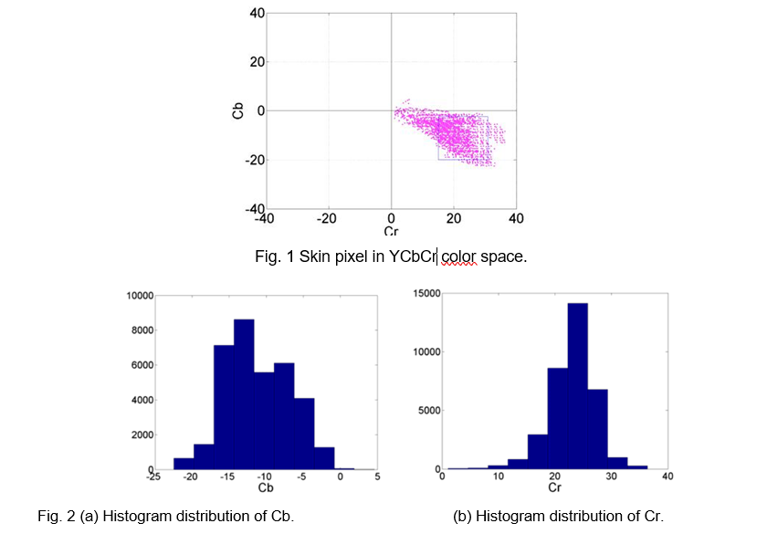

The color segmentation has been applied to a training image and its result is shown in Fig. 3.

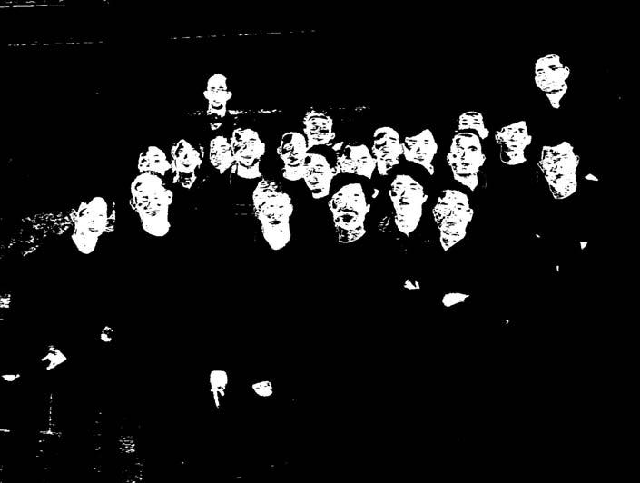Some non-skin objects are inevitably observed in the result as their colors fall into the skin color space.

Fig. 3 Color segmentation result of a training image.

**Image Segmentation**

The next step is to separate the image blobs in the color filtered binary image into individual regions. The process consists of three steps. The first step is to fill up black isolated holes and to remove white isolated regions which are smaller than the minimum face area in training images. The threshold (170 pixels) is set conservatively. The filtered image followed by initial erosion only leaves the white regions with reasonable areas as illustrated in Fig. 4.

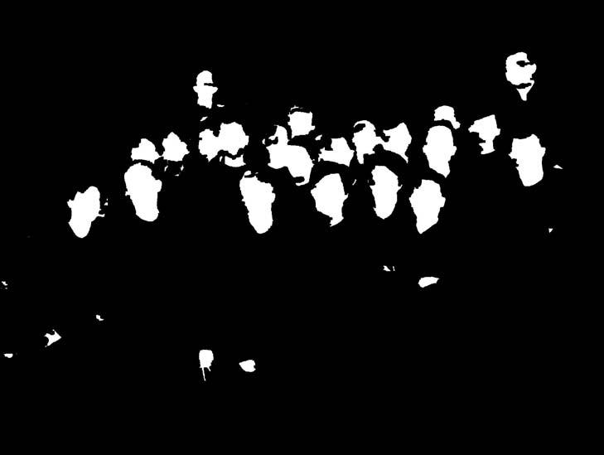

Fig. 4. Small regions eliminated image.

Secondly, to separate some integrated regions into individual faces, the Roberts Cross Edge detection algorithm is used. The Roberts Cross Operator performs a simple, quick to compute, 2-D spatial gradient measurement on an image. It thus highlights regions of high spatial gradients that often correspond to edges. (Fig. 5.)The highlighted region is converted into black lines and eroded to connect crossly separated pixels.

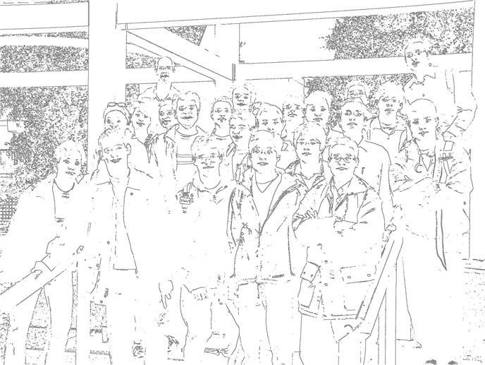

Fig.5. Edges detected by the Roberts cross operator.

Finally, the previous images are integrated into one binary image and relatively small black and white areas are removed. The difference between this process and the initial small area elimination is that the edges connected to black areas remain even after filtering. And those edges play important roles as boundaries between face areas after erosion. Fig. 6. shows the final binary images and some candidate spots that will be compared with the representative face templates in the next step are introduced in Fig. 7.

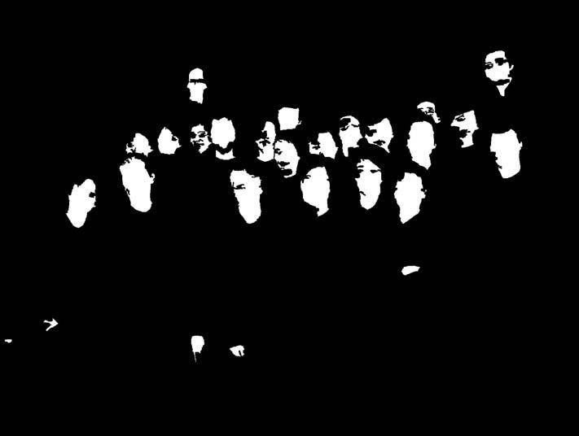

Fig.6. Integrated binary image.

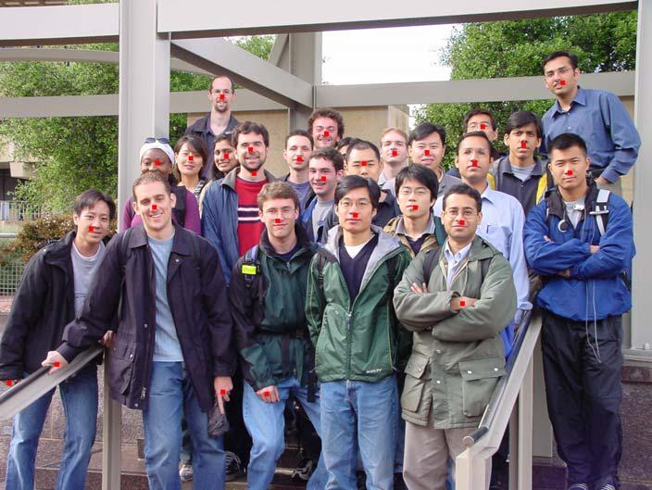

Fig.7. Preliminary face detection with red marks.

**Image Matching**

**Eigenimage Generation**

A set of eigenimages was generated using 106 test images which were manually cut from 7 test images and edited in *Photoshop* to catch exact location of faces with a square shape. The cropped test images were converted into gray scale, and then eigenimages were computed using those 106 test images. In order to get a generalized shape of a face, the largest 10 eigenimages in terms of their energy densities, have been obtained as shown in the Fig. 8. To save computing time, the information of eigenimages was compacted into one image which was acquired after averaging the first 9 eigenimages excluding the eigenimage 1, the highest-energy one. The first image was excluded due to its excessive energy concentration which will eliminate the details of face shapes that can be shown from other eigenimages from eigenimage 2 to eigenimage 10. The averaged eigenimage is shown in Fig. 9.

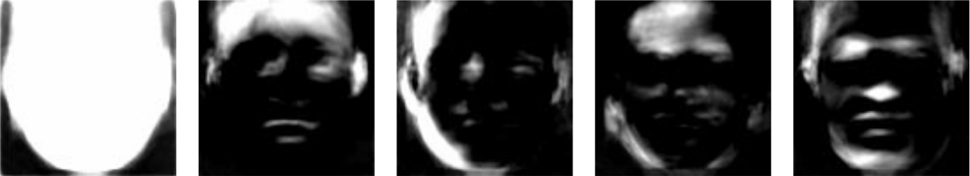

eigenimage 1 eigenimage2 eigenimage 3 eigenimage 4 eigenimage 5

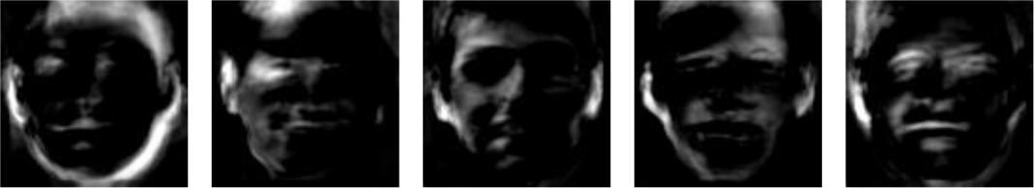

eigenimage 6 eigenimage 7 eigenimage 8 eigenimage 9 eigenimage 10

Fig.8. Eigenimages

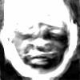

Fig.9. Average image using eigenimages

**Building Eigenimage Database**

In order to save time to magnify or shrink an eigenimage to meet the size of the test image, a group of eigenimages was stored in the database so that an appropriate eigenimage can be called with ease without going through image enlarging or shrinking process. The eigenimages were stored in 20 files from 30 pixel-width square image to 220 pixel-width square image with 10-pixel step. The stored eigenimages were normalized by means of dividing the image matrix by its *2nd norm* so that the effect of eigenimage size does not affect the face detection algorithm.

**Test Image Selection**

After the color-based segmentation process, skin-colored area can be taken apart as shown in Fig. 6. Given this binary image, a set of small test images needs to be selected and passed to the image matching algorithm for the further process. The result of image selection solely based on the color information is shown in Fig. 10. A square box was applied on each segment with the quantified window size which was selected to meet the size of a face.

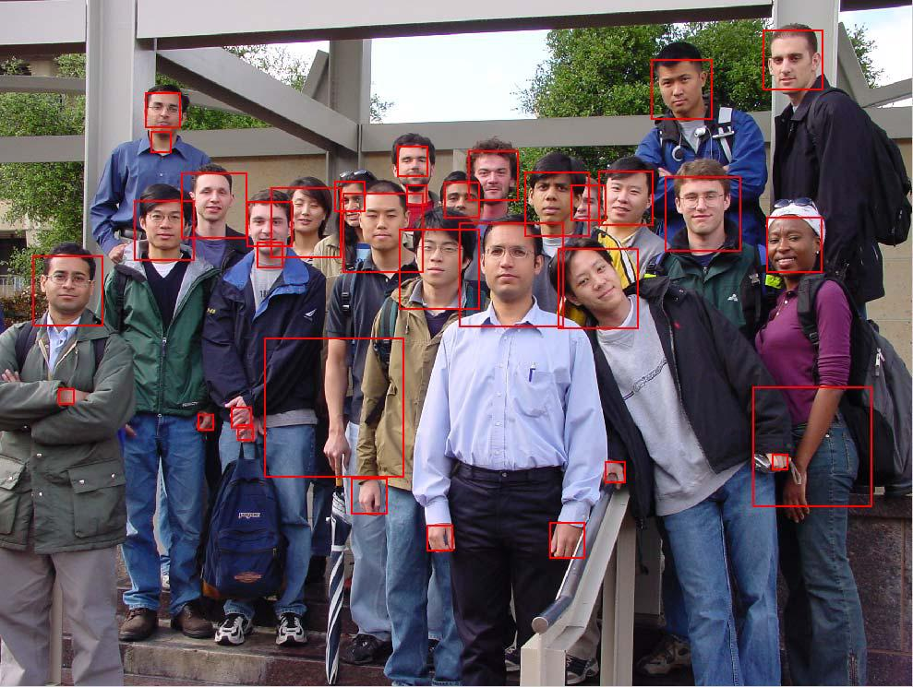

Fig. 10. Test Image Selection using Color-Based Image Segmentation.

If Fig. 10 is examined closely, some faces are divided into several pieces, for example the face being separated into its upper part and neck part as seen in Fig. 11 (a). This is due to the erosion process which was applied to evade *occlusion*. To merge these separate areas into one area, *box-merge algorithm* was used which simply merges two or more adjacent square boxes into one. Since thisphenomenon happens between face and neck part most of times, distance threshold was set small for horizontal direction, while set large for vertical direction. The results after merging two boxes in Fig. 11 (a) are shown in Fig. 11 (b). After applying this algorithm, it can be found that only one box is placed per face most of times in Fig. 12.

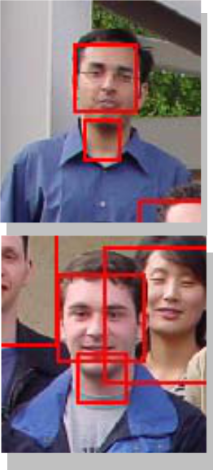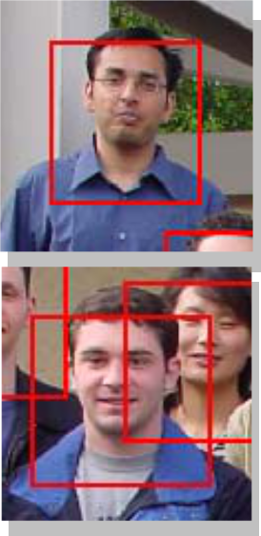

(a) before merging process (b) after merging process

Fig. 11. Test Image Selection: Merging of Adjacent Boxes.

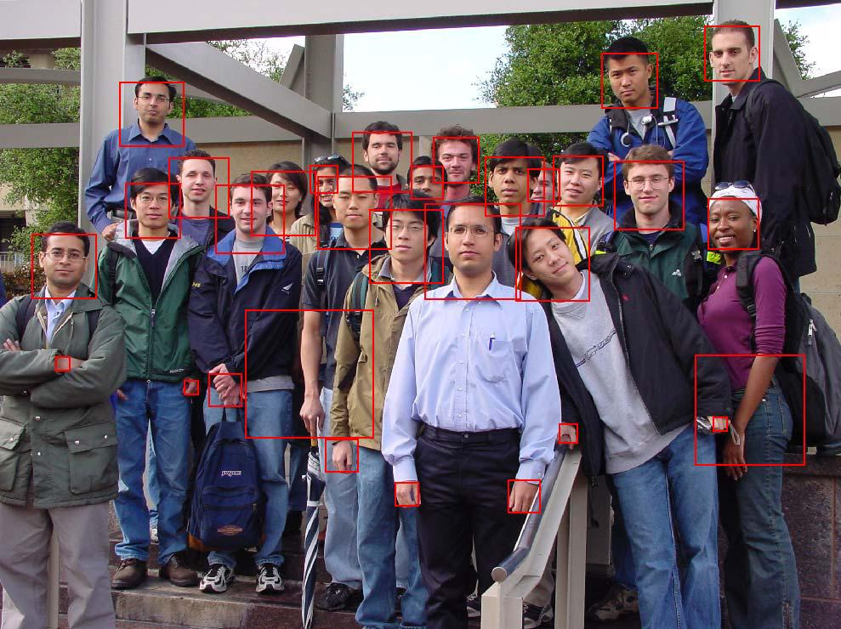

Fig. 12. Test Image Selection after Applying *Box-Merge Algorithm.*

**Correlation**

The test images selected by an appropriate square window can be passed to the image matching algorithm. Before the image matching process, the test image need to be converted to gray scale, and should be divided by the *average brightness* of the image in order to eliminate the effect of the brightness of the test image in the process of image matching. *Average brightness* was defines as *2nd norm* of the skin-colored area of the test image. Note that it is not the *2nd norm* applied to the total areaof the test image, since the value that we are looking for is not the average brightness of the test image, but the average brightness of the skin colored parts only.

With the normalized test image, the image matching can be simply accomplished by loading a correspondent file of eigenimage from the database, then performing correlation of the test image with respect to the loaded eigenimage. The results of image matching are illustrated in Fig. 13. The number inside each window means the ranking of the correlation value.

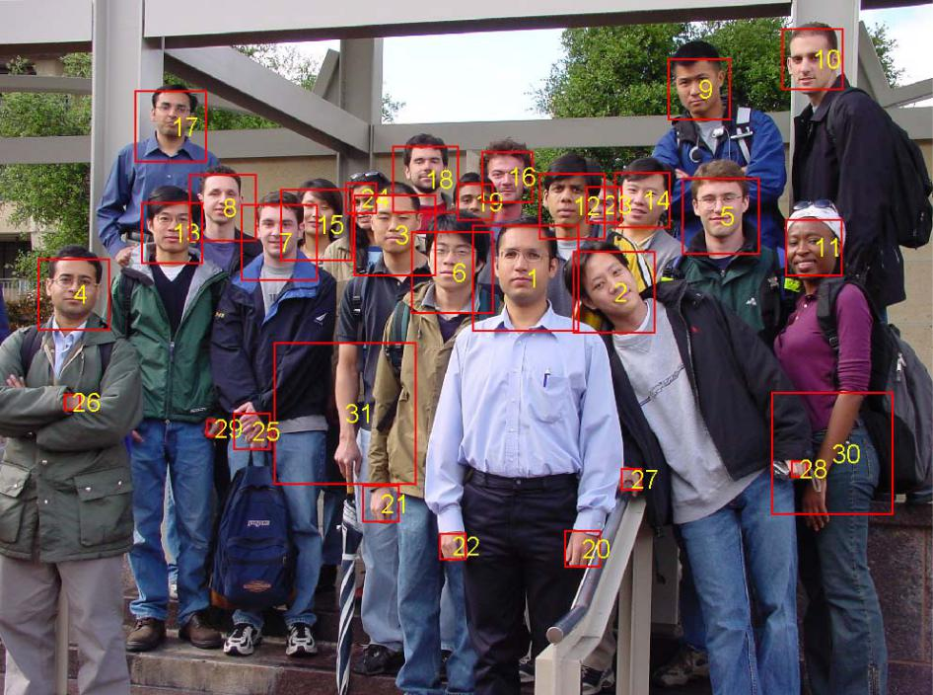

Fig. 13. Selected Test Images with Correlation Ranking Information*.*

**Distance Compensation**

Since the figure to be tested will be a group picture, faces in the figure are located close to the each other in the central area of the figure. However, hands, arms, or legs are relatively located far from the faces in the figure. Therefore, the mean square distance of a test image with respect to other test images can be calculated, and then its reciprocal can be multiplied to the correlation value obtained above, to take the geographical information into account. In other words, a test image which is located close to the other test images will get larger correlation value, while a test image which is far from the other group will have smaller correlation value. The ranking of the correlation values of the test images after this evaluation is shown in Fig. 14

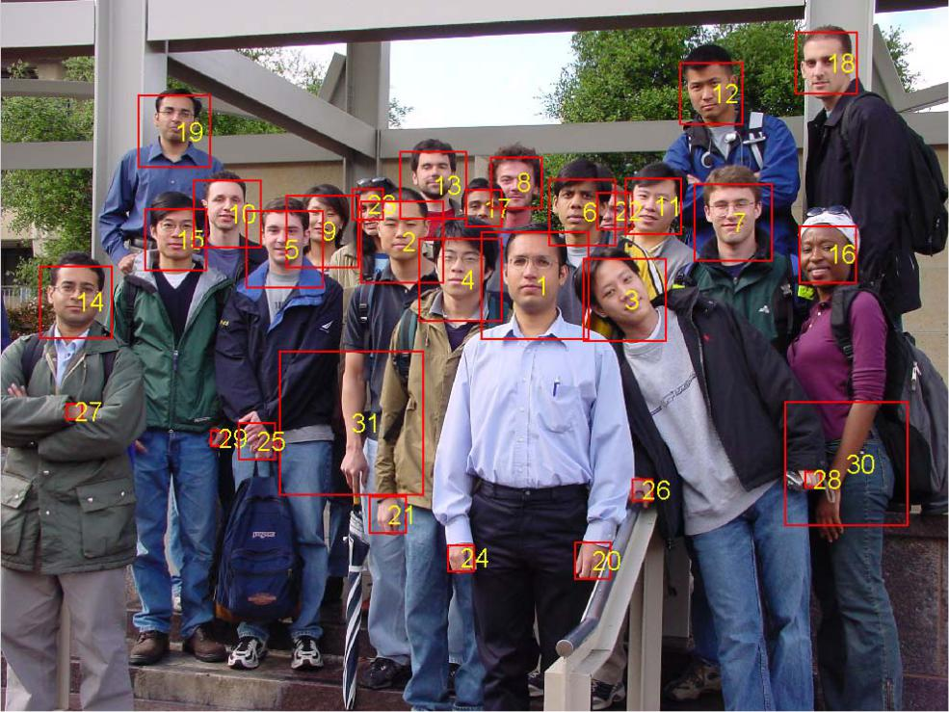

Fig. 14. Correlation Ranking after Geographical Consideration.

**Filtering Non-facial Test Images using Statistical Information**

The next step is filtering out non-facial test images from the figure. Several approaches have been taken, but it was not easy to find an absolute threshold value which can be applied to various pictures with different light condition and composition. Approaches using luminance, *average brightness,* and etc., have been tried, but they turned out not to be good enough to set an appropriate threshold for filtering out non-facial test images. Lastly statistical method was tried. As seen in the Fig. 15, the histogram of the correlation values after geographical consideration shows wide distribution of the output values. The leftmost column corresponds to the test images which have smallest correlation values among the set of the test images.

After filtering out the leftmost column elements, which is 12 test images for this example figure, Fig. 16 was obtained. Out of 21 faces in the picture, the algorithm has detected 19 faces within acceptable error of the location of faces. The two undetected faces are partially blocked by the other faces. Conclusively, this statistical approach, which is seemingly rough estimation, works great in this picture, and is turned out to produce good results for other pictures as well.

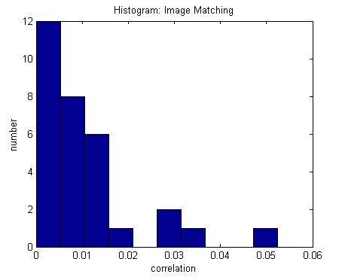

Fig. 15. Histogram: Image Matching.

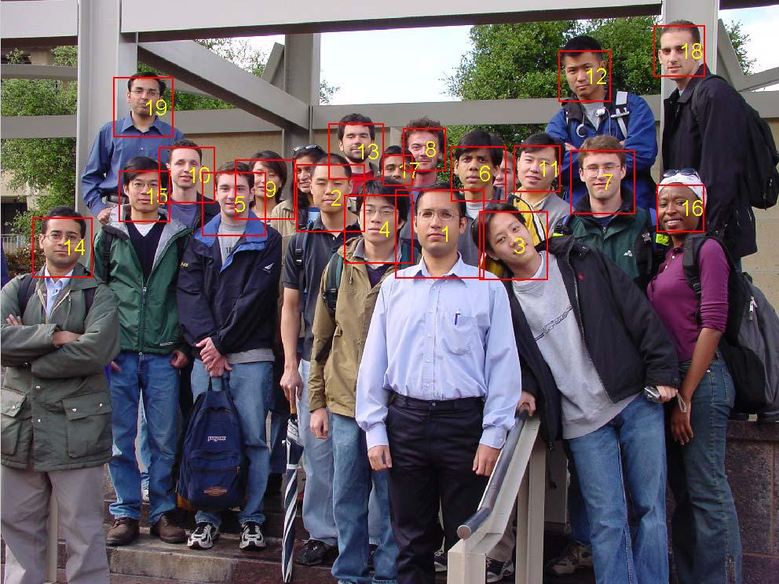

Fig. 16. Correlation Ranking after Geographical Consideration.

**Design Methodology**

As we mentioned before in (Figure 1.1). The project process is:

A camera will take continuous stream.

In LABVIEW, IMAQ library for vision will be used. Convert the RGB image to grayscale image.

Then perform Machine Vision Algorithm and match with patterns stored in our database. If pattern matches based on the score of how successful, decide to mark attendance or

not.

Update the marked attendance in a measurement file.

**Product Subsystems and Components**

***Product Subsystem1: Vision Acquisition***

This subsystem is used to acquire continuous stream of video from attached camera. It starts a camera session from desired camera and transmits its image feed to further processing. The feed captured is inline processed and then the next feed is captured as shown in (Figure 3.1).

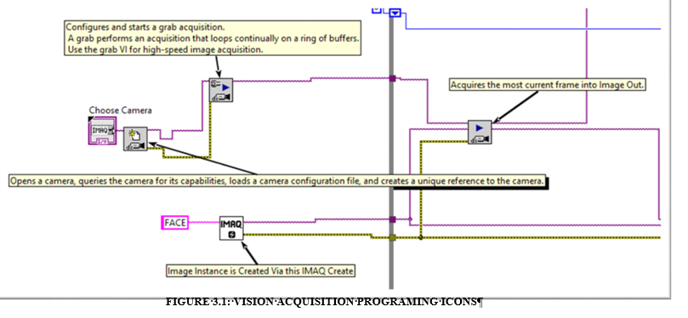

This module converts an RGB (32bit) image to Grayscale (Unsigned 8 bit) image. This is requirement of Vision Assistant Processing whose image input must be 8 bits as shown in (Figure3.2).

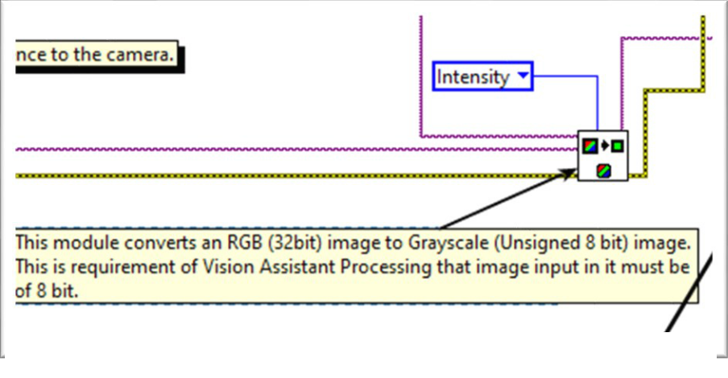

**FIGURE 3.2: GRAYSCALE VISION CONVERSION ICON**

In (Figure 3.3) Vision Assistant helps us to perform Machine Vision Algorithm Pattern Matching on our image. This allows us to detect faces of student in a group of class. First one must add student faces as template in this program to create a database of images using reference images. The result is outputed which includes the information of score 0-1000 to tell how successful a match was, position of match occurred in image, angle of match occurred in image. This information together with number of matches for each user will be used to mark attendance of user in future progresses.

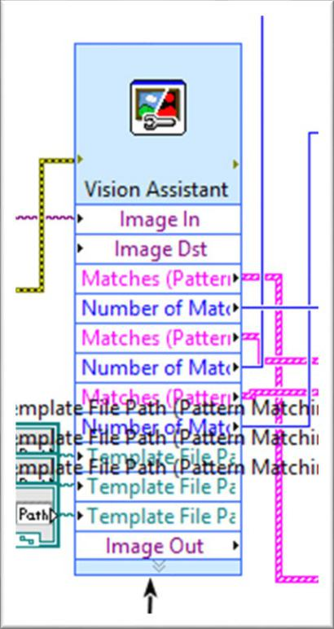

**FIGURE 3.3: VISION ASSISTANT ICON**

***Product Subsystem4: Writing in a Measurement File***

Each Student name and his/her attendance is marked if the case is true, else the attendance marked absent. The file path to the spread sheet delimiter is provided and the delimiter used to separate each student data is new line (new row). The system also caters a latch in form of a OR gate in which once a student is detected the system will maintain its value no matter if he/she gets out of frame and is undetected as demonstrated in (Figure 3.4).

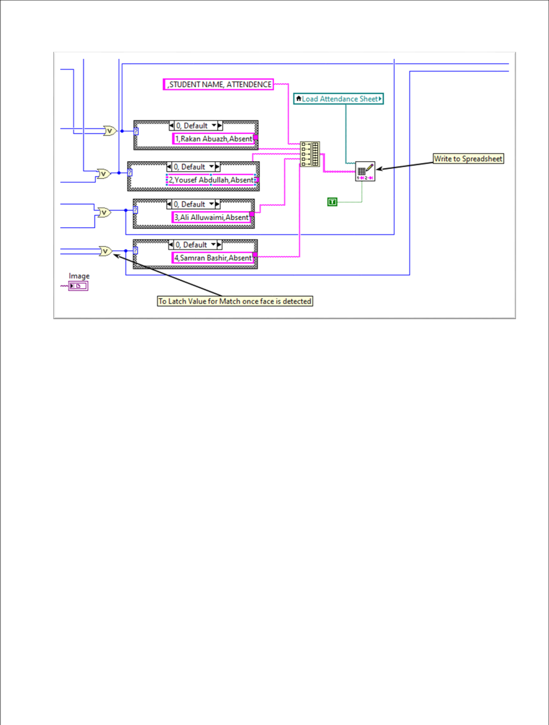

**FIGURE 3.4: WRITING ON SPREADSHEET NAMES**

**Implementation**

**THE MAIN MENU:**

This is the first prompt to appear when program is run. It will ask user to either proceed further for face detection or exit the program as demonstrated in (Figure 3.5).

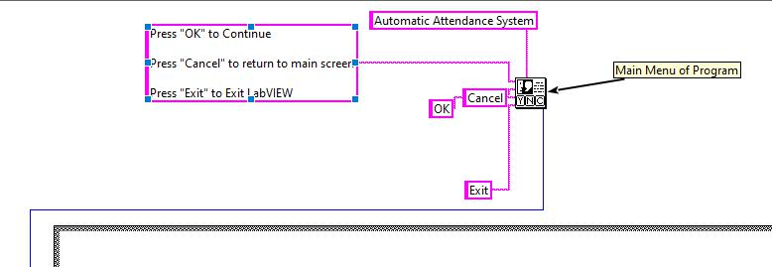

**FIGURE 3.5: MAIN MENU ICONS**

**THE VISION ACQUISITON MODULES:**

Vision acquisition is responsible of the live camera in front panel, changing the image to greyscale so the Vision Assistant can accept it, and the camera choice as shown in (Figure 3.6).

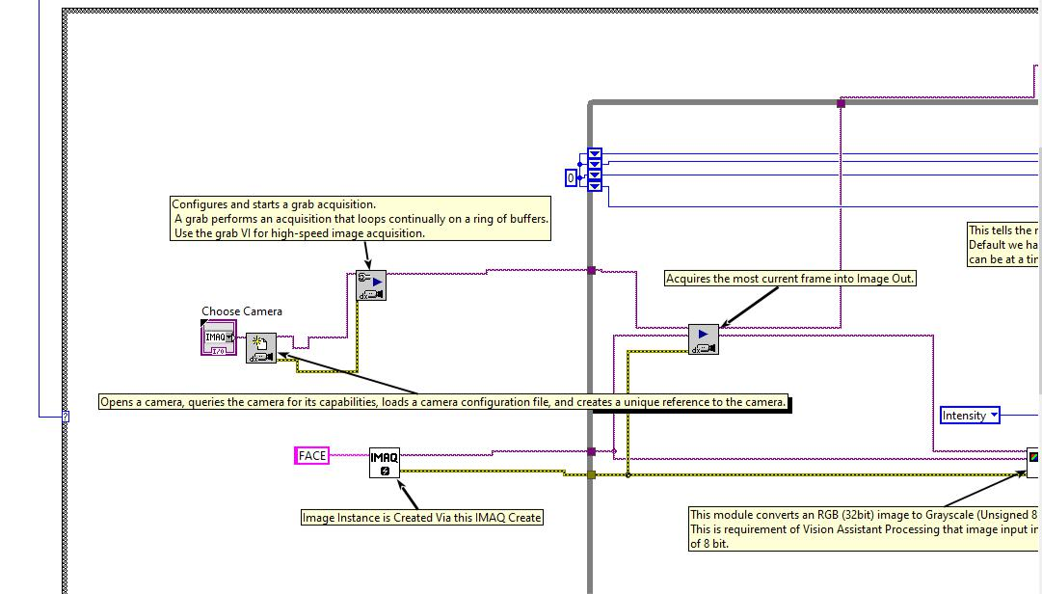

**FIGURE3.6: VISION ACQUISITION MODULES**

This is the front panel where the capture picture of the class is shown in image out. We have to add path for the save attendance file where it needs to be stored and also the path of the pattern of each student, three cases are generated. You can increase the pattern from Vision Assistant block as already stated above. The marked attendance is updated in the file and also shown in the indicator in front panel as shown in (Figure 3.9).

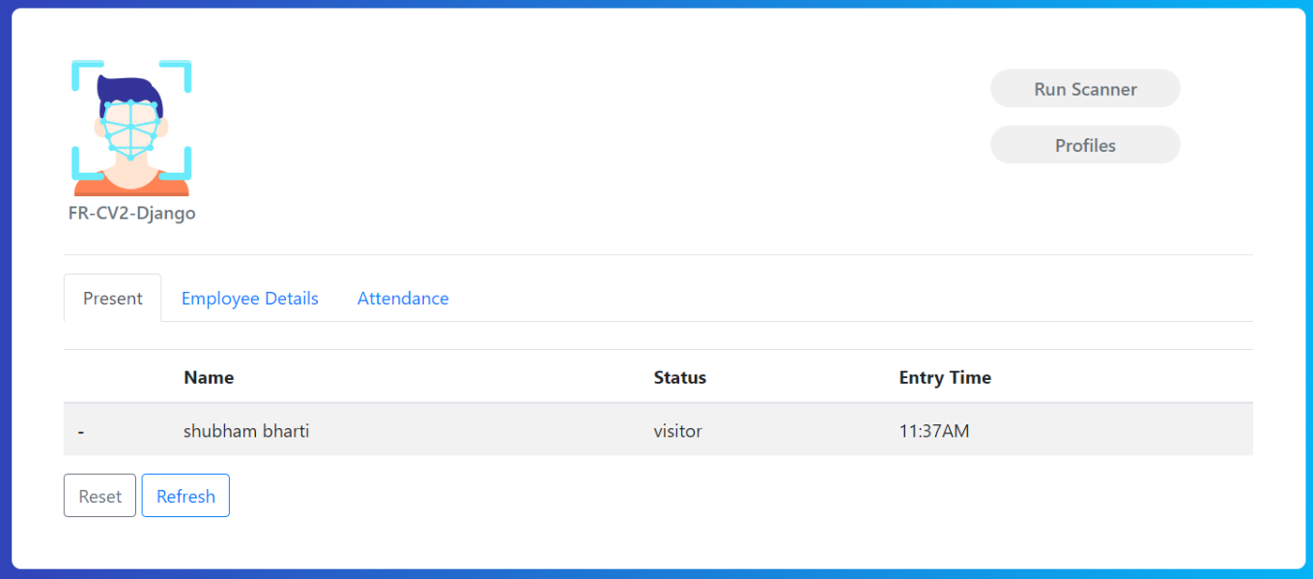

**FIGURE3.9: FRONT PANEL**

**Chapter:4**

**SYSTEM TESTING AND ANALYSIS**

**System Testing and Analysis**

After running this server, the interface will come as shown in figure Here are two options like **Run Scanner** and **profiles**

**Profiles =>** will provide you a frame as how many students or teachers profiles are available Where are again two options, they are **Add Profile** and **Return**

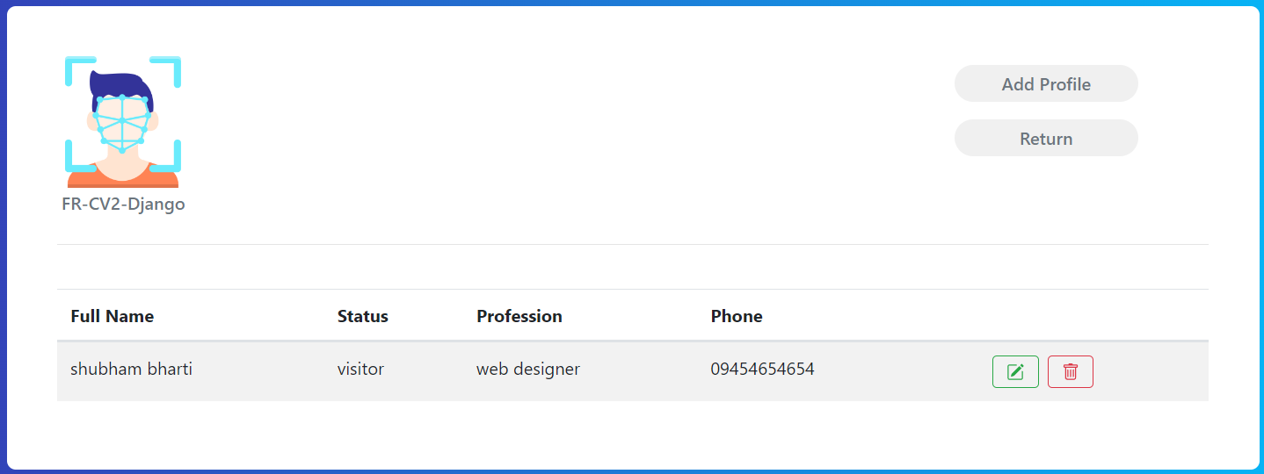

Fig: Profile Page

**Add profile =>** Here are some details and photo are to be filled to add a new student or teacher

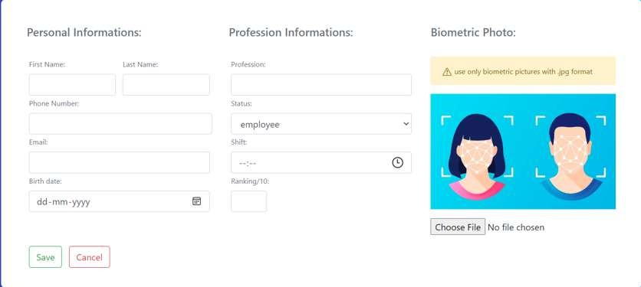

Fig: Add Profile

**Run Scanner =>** will launch a camera, after recognition name will be appeared under the photo has been provided by the user

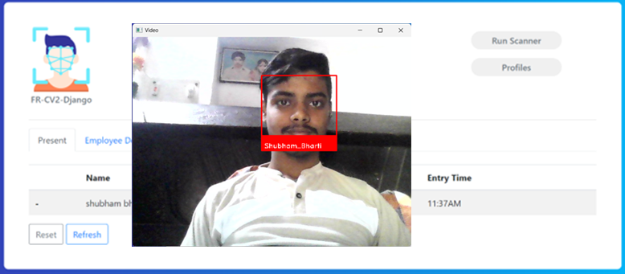

Fig: Scanner Page

**Complete profile** will appear after being detected

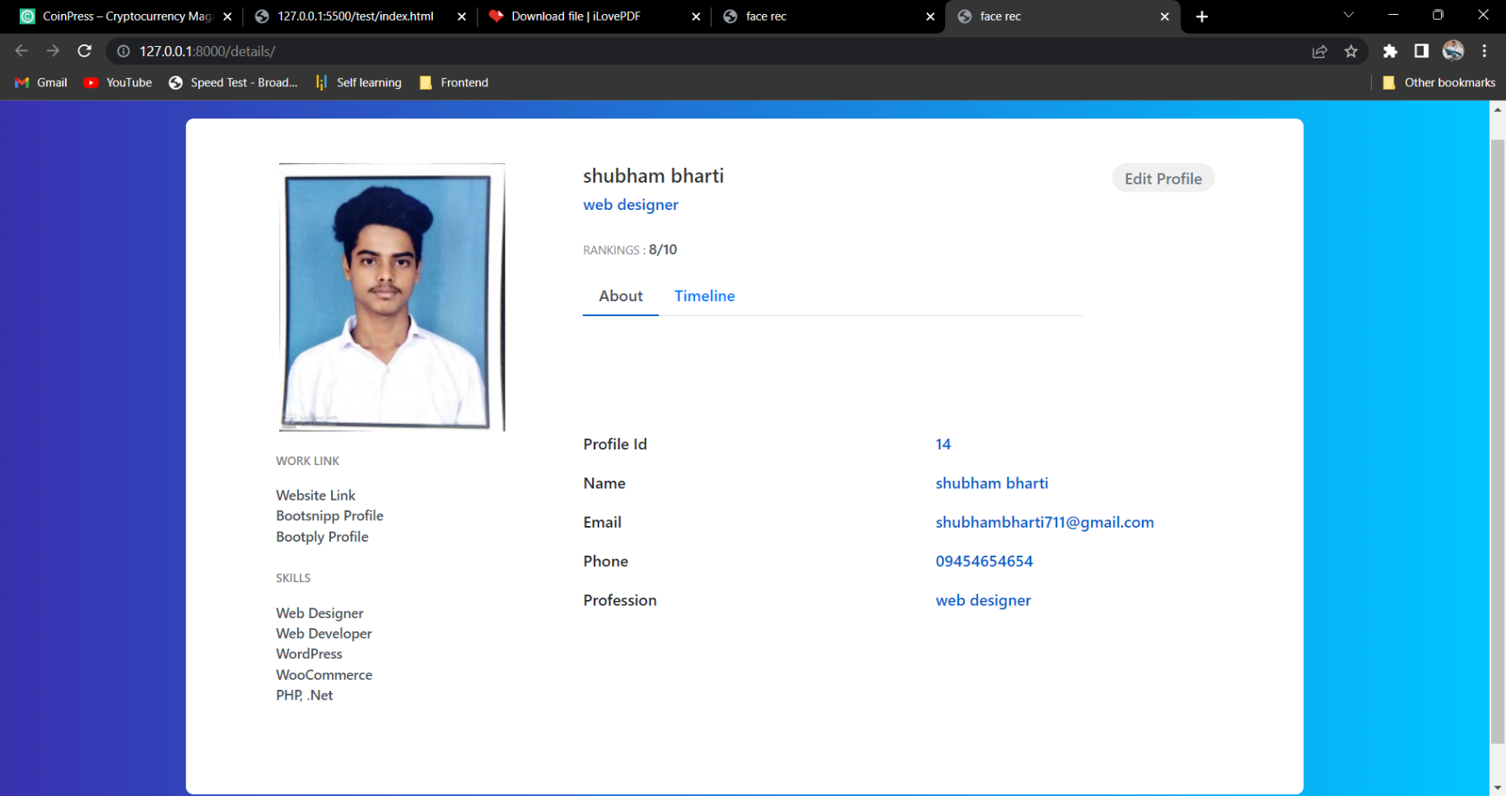

Fig: Employee Profile

**Edit profile =>** here user can change its details anytime according to its needs

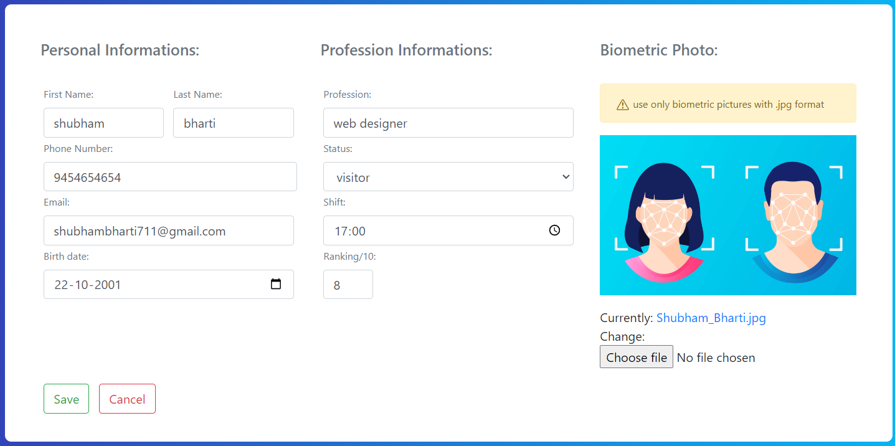

Fig: Edit Profile

**Chapter:5**

**PROJECT MANAGEMENT**

**Project Plan**

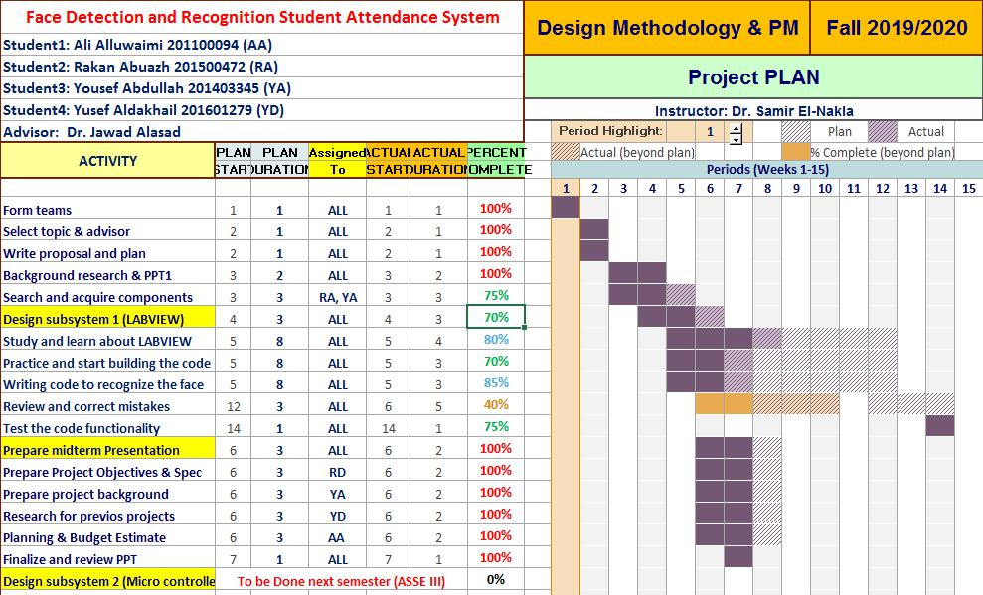

**FIGURE: PROJECT PLAN FOR SEMESTER #1**

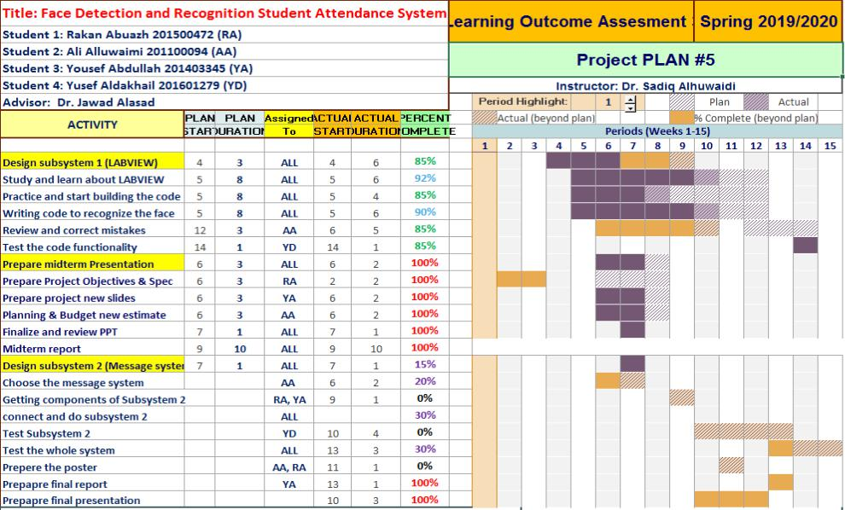

**FIGURE: PROJECT PLAN FOR SEMESTER #2**

**Contribution of Team Members**

As group, we managed to divide the work between us as shown in (Table 1). We were collaborating and meeting with each other, however after the college we were doing virtual meetings in order to try our best to work on the project despite what is happening.

**Project Execution Monitoring**

***Meeting With Advisor***

Proper meeting with advisor was held biweekly to discuss the issue that became halt in the progress of the project. Advisor helped with the necessary solution for the required problem.

***Team Meeting***

All members discuss their respective progress in their part in daily meeting and prepare a final sheet for the meeting with the advisor.

***Testing***

After completion of each part mentioned in project plan, proofreading and testing was done for successful verification of the part.

An overall progress discussion meeting was held once a month where current standing of the project is presented to the advisor and everyone including members share their opinion and discuss them, and what amendments are necessary to be added.

**Limitation and Challenges**

1. Sometime detects wrong data for wrong person due to same features of face
2. System can be corrupted
3. Data might be stolen by someone
4. Data base can be limited
5. Due to heavy entries, recognition process may affected

**Project Analysis**

**Life-long Learning**

With the implementation of this project, we gained skills on the commands of LabView specifically Vision Assistant and Acquisition based modules. Understanding of Machine Vision Algorithm for face detection and reading manual of LabView enhances our skills on the LabView. Furthermore, the project management skills we gained by dividing the project into different phases and time slot not only developed our project management skills but also increased our time management skills.

**Impact of Engineering Solutions**

This project saves time for the lecture by taking attendance on its own and update the attendance record. So that, additional time can be given to the topic for better understanding. Furthermore, it will be easy to sort the attendance according to the student roll no. and name while updating the student report for mentioning his/her attendance record. With the help of simple processing, we can estimate the student attendance record with an algorithm and if their attendance is less than 75%, send a notice mail or message to their parents.

**Contemporary Issues Addressed**

Before face recognition was even possible and available for larger use by just state agencies and airport, people suggest that we all have distinct fingerprint and that same thought could be contributed to our facial features. With the help of face detection, we are moving towards safer network security for the society and it is the most effective way to protect your information. Face detection technology is vast and is now being used in every department and firm in Saudi Arabia.

**Conclusions and Future Recommendations**

**Conclusions**

Number of modules are available on LabVIEW to achieve incredible number of tasks. The best thing about LabVIEW is that you can view the flow of data from one block to other and have more freedom to make changes according to your requirements. The Automatic Class Attendance System implemented in this project would be much more difficult if it was not implemented on LabVIEW. The objective of class attendance system is to automate the time consuming and error prone attendance system.

There are always limitations of every system. One can only have fixed number of students and provide less freedom to have interclass attendance system. This means the attendance system for one class can’t be used for attendance system of other class. One must change programming to do this.

The Project experience was tremendous as we learned the core of vision algorithms and different programming techniques of LabVIEW. We learned how can a problem be simplified into smaller tasks and can be achieved successfully. It is the reason why we are able to complete our project in 1st of the two semesters.

The goal of the project was to build a facial recognition system for student’s attendance. Concepts of facial recognition and LBPH is heavily discussed in this thesis. Similarly, web development with Django is also discussed, followed by examples of implementation and explanations.

The result of the project was a successful prototype of a facial recognition system where the admin can create a teacher account and add students and their information to the database.

Teachers then can log in to the system and take attendance of the student. The student’s face is detected by a camera and attendance is recorded in the database. Teachers and admin could see the attendance report of the students.

Overall, the project was successful in its showcasing how LBPH can be implemented in Django to create a web application. Once implemented, it can be used to take attendance of students and keep track of their attendance records. This project has the potential for further development in the future by adding more features for students and teachers. More features such as assignments, results, and grades could be added.

**Future Work and Expected Final Prototype/Results**

Due to COVID-19 pandemic we were left with10% of our project is being left and the list of unfinished parts:

1. Scaling the number of attendees (which can be done easily by any user).
2. Optimizing the synchronization between LABVIEW and Excel attendance sheet.

Our project can be implemented in a computer and then the user take pictures (or upload them) to the vision assistant and add their names of the desired students in excel sheet.

**Future Recommendations**

The system can be made more flexible and scalable using these recommendations. Please note that the system implemented here is just a prototype of idea presented via this project. The recommendations are as follows:

The system can be extended to more number of students with freedom to change list of students according to class changes.

The system can be made more flexible to allow updating of templates in case student incurs significant amount of change in his facial features.

The system can also be extended to allow better face recognition algorithm in which even rotational features of face can be detected efficiently.

**References**

<https://www.alibaba.com/product-detail/Original-Hik-vision-8MP-WDR-H_60752337217.html?spm=a2700.details.deiletai6.1.584755a0Lhzdop>

<http://www.ni.com/en-lb/shop/select/labview?skuId=495092>

[https://www.researchgate.net/publication/326986115_Face_Detection_and_Recognition_Student_Atten](https://www.researchgate.net/publication/326986115_Face_Detection_and_Recognition_Student_Attendance_System)

[dance_System](https://www.researchgate.net/publication/326986115_Face_Detection_and_Recognition_Student_Attendance_System)

[http://erepository.uonbi.ac.ke/bitstream/handle/11295/76598/Kagiri_Enhancing%20community%20base](http://erepository.uonbi.ac.ke/bitstream/handle/11295/76598/Kagiri_Enhancing%20community%20based%20health%20information%20system%20CBHIS%20reporting?sequence=4&isAllowed=y)

[d%20health%20information%20system%20CBHIS%20reporting?sequence=4&isAllowed=y](http://erepository.uonbi.ac.ke/bitstream/handle/11295/76598/Kagiri_Enhancing%20community%20based%20health%20information%20system%20CBHIS%20reporting?sequence=4&isAllowed=y) <http://eprints.utar.edu.my/2861/1/CT-2018-1503979-2.pdf>